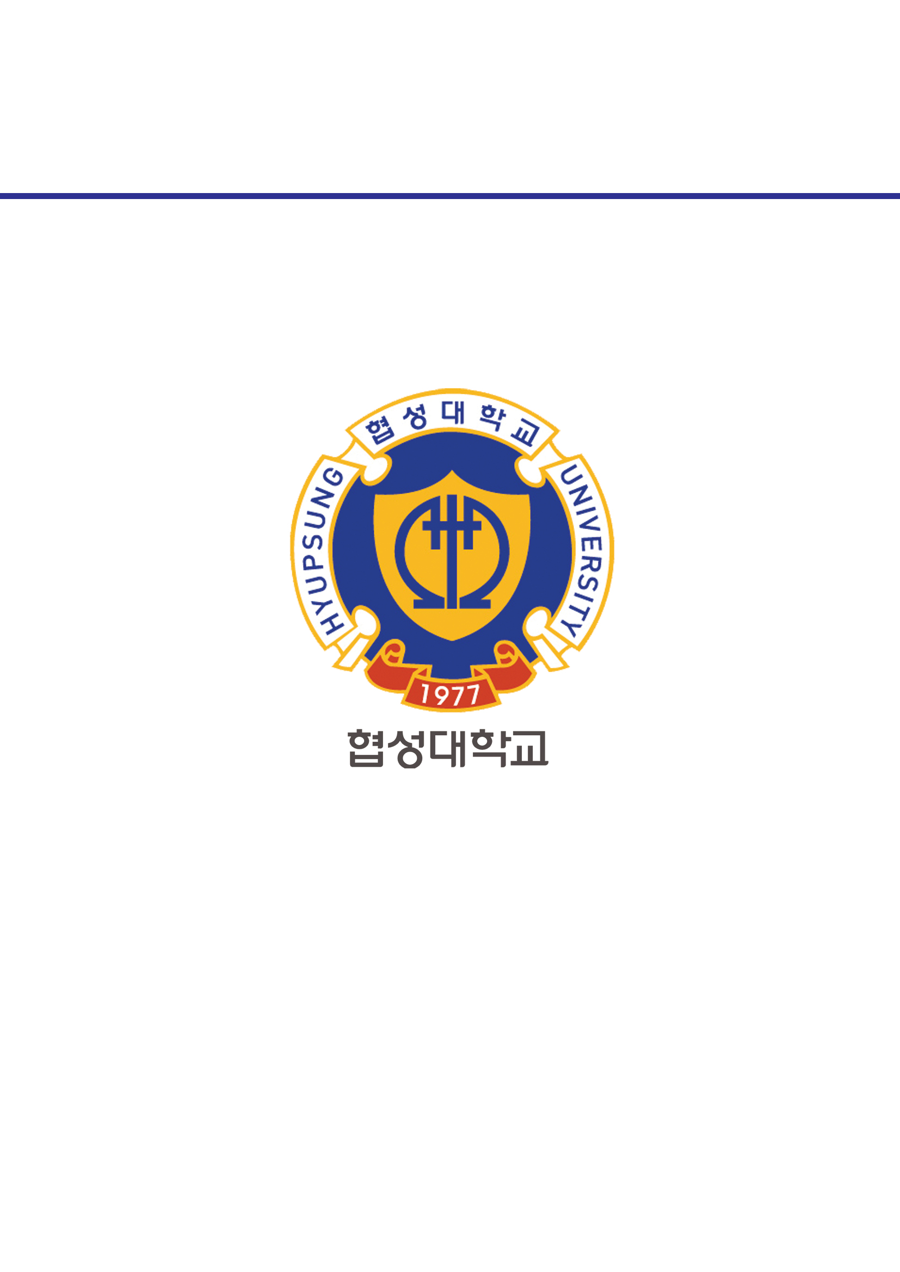­­

과목명 : IOT시스템응용

담당교수 : 봉진숙

학번 : 20170660

학과 : 컴퓨터공학과

이름 : 김동현

**REPORT**

**1. tcpexam**

코드) ServerExample.java

**package tcpexam;**

**import java.io.IOException;**

**import java.net.InetSocketAddress;**

**import java.net.ServerSocket;**

**import java.net.Socket;**

**public class ServerExample {**

**public static void main(String[] args) {**

**ServerSocket serverSocket = null;**

**try {**

**serverSocket = new ServerSocket(5001);**

**while(true) {**

**System.out.println("[연결 기다림]");**

**Socket socket = serverSocket.accept();**

**InetSocketAddress isa = (InetSocketAddress)socket.getRemoteSocketAddress();**

**System.out.println("[연결 수락함]" + isa.getAddress().getHostAddress());**

**}**

**} catch (IOException e) {**

**// TODO Auto-generated catch block**

**e.printStackTrace();**

**}**

**if(!serverSocket.isClosed()) {**

**try {**

**serverSocket.close();**

**} catch (IOException e) {**

**// TODO Auto-generated catch block**

**e.printStackTrace();**

**}**

**}**

**}**

**}**

실행 결과)

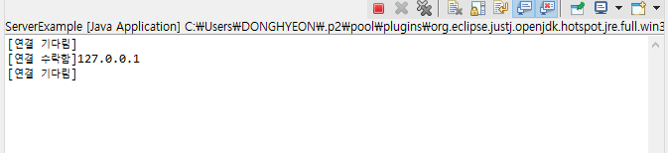

코드) ClientExample.java

**package tcpexam;**

**import java.io.IOException;**

**import java.net.InetSocketAddress;**

**import java.net.Socket;**

**public class ClientExample {**

**public static void main(String[] args) {**

**Socket socket = null;**

**socket = new Socket();**

**try {**

**System.out.println("[연결 요청]");**

**socket.connect(new InetSocketAddress("localhost", 5001));**

**System.out.println("[연결 성공]");**

**} catch (IOException e) {**

**// TODO Auto-generated catch block**

**e.printStackTrace();**

**}**

**if(!socket.isClosed()) {**

**try {**

**socket.close();**

**} catch (IOException e) {**

**// TODO Auto-generated catch block**

**e.printStackTrace();**

**}**

**}**

**}**

**}**

실행 결과)

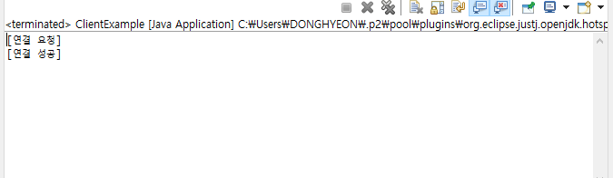

**2. data_write_read**

코드) ServerExample.java

**package data_write_read;**

**import java.io.IOException;**

**import java.io.InputStream;**

**import java.net.InetSocketAddress;**

**import java.net.ServerSocket;**

**import java.net.Socket;**

**public class ServerExample {**

**public static void main(String[] args) {**

**ServerSocket serverSocket = null;**

**try {**

**// serverSocket = new ServerSoekcet(5001);**

**serverSocket = new ServerSocket();**

**InetSocketAddress ipep = new InetSocketAddress(5001);**

**serverSocket.bind(ipep);**

**while(true) {**

**System.out.println("[연결 기다림]");**

**Socket socket = serverSocket.accept();**

**InetSocketAddress isa = (InetSocketAddress)socket.getRemoteSocketAddress();**

**System.out.println("[연결 수락함]" + isa.getAddress().getHostAddress());**

**byte[] bytes = null;**

**String message = null;**

**InputStream is = socket.getInputStream();**

**bytes = new byte[100];**

**int readByteCount = is.read(bytes);**

**message = new String(bytes, 0, readByteCount, "UTF-8");**

**System.out.println("[데이터 받기 성공]" + message);**

**is.close();**

**socket.close();**

**}**

**} catch (IOException e) {**

**// TODO Auto-generated catch block**

**e.printStackTrace();**

**}**

**if(!serverSocket.isClosed()) {**

**try {**

**serverSocket.close();**

**} catch (IOException e) {**

**// TODO Auto-generated catch block**

**e.printStackTrace();**

**}**

**}**

**}**

**}**

실행 결과)

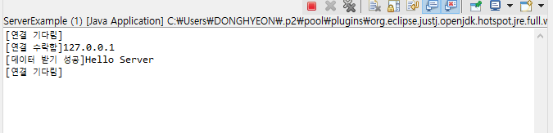

코드) ClientExample.java

**package data_write_read;**

**import java.io.IOException;**

**import java.io.OutputStream;**

**import java.net.InetSocketAddress;**

**import java.net.Socket;**

**public class ClientExample {**

**public static void main(String[] args) {**

**Socket socket = null;**

**socket = new Socket();**

**try {**

**System.out.println("[연결 요청]");**

**socket.connect(new InetSocketAddress("localhost", 5001));**

**System.out.println("[연결 성공]");**

**byte[] bytes = null;**

**String message = null;**

**OutputStream os = socket.getOutputStream();**

**message = "Hello Server";**

**bytes = message.getBytes("UTF-8");**

**os.write(bytes);**

**os.flush();**

**System.out.println("[데이터 보내기 성공]");**

**os.close();**

**} catch (IOException e) {**

**// TODO Auto-generated catch block**

**e.printStackTrace();**

**}**

**if(!socket.isClosed()) {**

**try {**

**socket.close();**

**} catch (IOException e) {**

**// TODO Auto-generated catch block**

**e.printStackTrace();**

**}**

**}**

**}**

**}**

실행 결과)

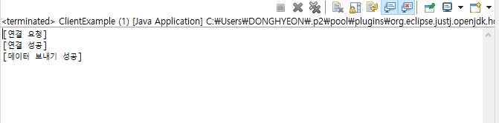

**3. echoExam**

코드) EchoServer.java

**package echoExam;**

**import java.io.BufferedReader;**

**import java.io.IOException;**

**import java.io.InputStream;**

**import java.io.InputStreamReader;**

**import java.io.OutputStream;**

**import java.io.PrintWriter;**

**import java.net.ServerSocket;**

**import java.net.Socket;**

**public class EchoServer {**

**private ServerSocket server;**

**public EchoServer(int port) throws IOException {**

**server = new ServerSocket(port); // 듣기 소켓이 생성(포트 번호까지 바인딩 된)**

**}**

**public void service() throws IOException {**

**System.out.println("EchoServer is ready");**

**Socket client = server.accept();**

**InputStream is = client.getInputStream();**

**OutputStream os = client.getOutputStream();**

**BufferedReader in = new BufferedReader(new InputStreamReader(is));**

**PrintWriter out = new PrintWriter(os, true);**

**while(true) {**

**String msg = in.readLine();**

**System.out.println(msg);**

**if(msg.equals("bye")) {**

**break;**

**}**

**out.println(">>" + msg);**

**}**

**}**

**public void close() throws IOException {**

**server.close();**

**}**

**public static void main(String[] args) {**

**EchoServer es;**

**try {**

**es = new EchoServer(1289);**

**es.service();**

**es.close();**

**} catch (IOException e) {**

**// TODO Auto-generated catch block**

**e.printStackTrace();**

**}**

**}**

**}**

실행 결과)

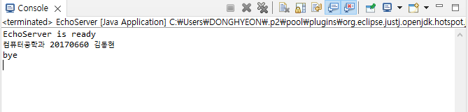

코드) EchoClient.java

**package echoExam;**

**import java.io.BufferedReader;**

**import java.io.IOException;**

**import java.io.InputStream;**

**import java.io.InputStreamReader;**

**import java.io.OutputStream;**

**import java.io.PrintWriter;**

**import java.net.Socket;**

**import java.net.UnknownHostException;**

**public class EchoClient {**

**private Socket socket;**

**public EchoClient(String host, int port) throws UnknownHostException, IOException {**

**socket = new Socket(host, port);**

**}**

**public void echo() throws IOException {**

**OutputStream os = socket.getOutputStream();**

**InputStream is = socket.getInputStream();**

**BufferedReader in = new BufferedReader(new InputStreamReader(is)); // 서버로 부터 온 애를 받아들이는**

**PrintWriter out = new PrintWriter(os, true);**

**BufferedReader con = new BufferedReader(new InputStreamReader(System.in)); // 사용자로부터 입력받은**

**while(true) {**

**String msg = con.readLine();**

**out.println(msg);**

**if(msg.equals("bye")) {**

**break;**

**}**

**System.out.println(in.readLine());**

**}**

**}**

**public void close() throws IOException {**

**socket.close();**

**}**

**public static void main(String[] args) {**

**EchoClient ec;**

**System.out.println("메시지를 입력하세요");**

**try {**

**ec = new EchoClient("localhost", 1289);**

**ec.echo();**

**ec.close();**

**} catch (UnknownHostException e) {**

**// TODO Auto-generated catch block**

**e.printStackTrace();**

**} catch (IOException e) {**

**// TODO Auto-generated catch block**

**e.printStackTrace();**

**}**

**}**

**}**

실행 결과)

